When we model a map using a graph, we will have the graph:

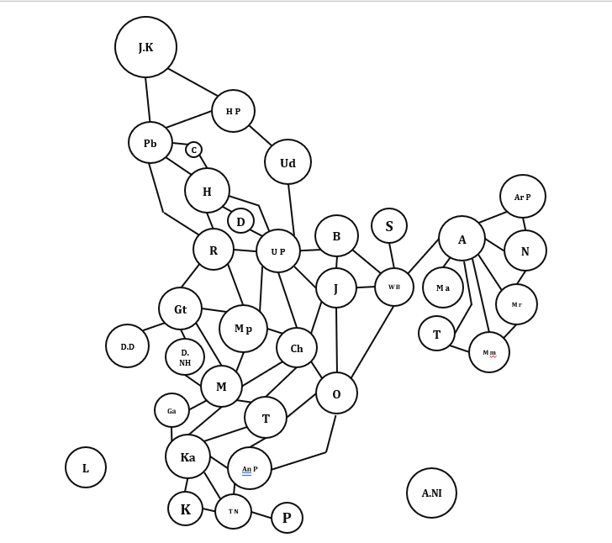

Using the Welsh-Powell graph coloring algorithm:

We denote color 1, color 2, color 3, and color 4 as red, yellow, purple, and green.

-Step 2: Color the vertex with the highest degree and simultaneously color the vertices that are not adjacent to it, including the vertex **Meghalaya**.:

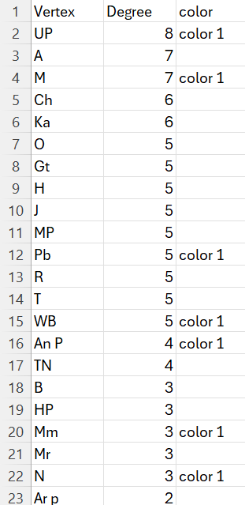

We will obtain the following graph after coloring:

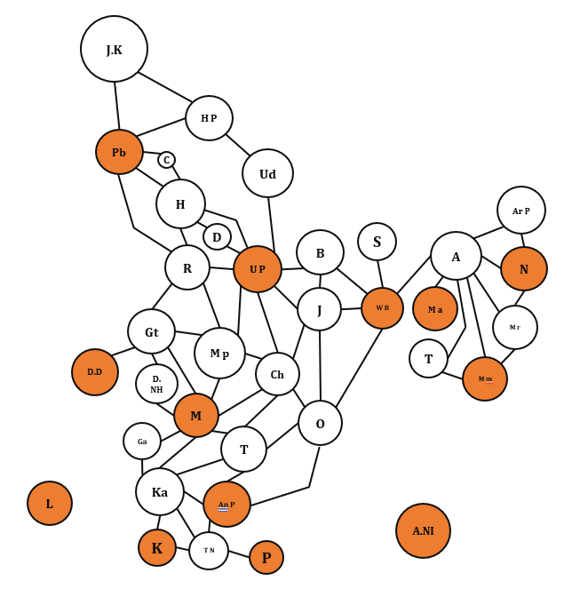

- Step 3: Then set the degree of the colored vertices to 0 and continue coloring the second color for the vertex with the highest degree, as shown in the figure

The graph after applying color 2 appears as follows:

-Step 4: Continue repeating step 3 and we will obtain the data as follows:

The graph after applying color 3 appears as follows:

-Step 5: Repeat step 3 in a similar manner

Conclusion:Using 4 colors,we have

- Red(Pb,UP,WB,Ma,Mm,N,D.D,M,AN P,L,K,P,A.NI)

-Yellow(HP,H,B,S,A,Gt,Ch,Ka)

-Purple(Ud,C,D,Ar P,Mr,T,Mp,D.NH,O,Ga,Tn)

-Green(R,J,T)